The way to find your courses……

Open www.pph-augustinum.at and click on the button PH-ONLINE

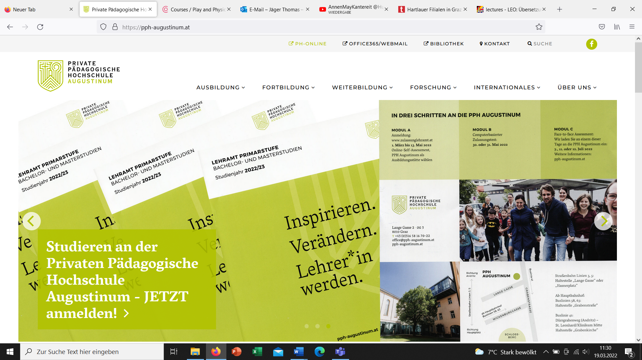

pho opens and you proceed with „weiter ohne Anmeldung“

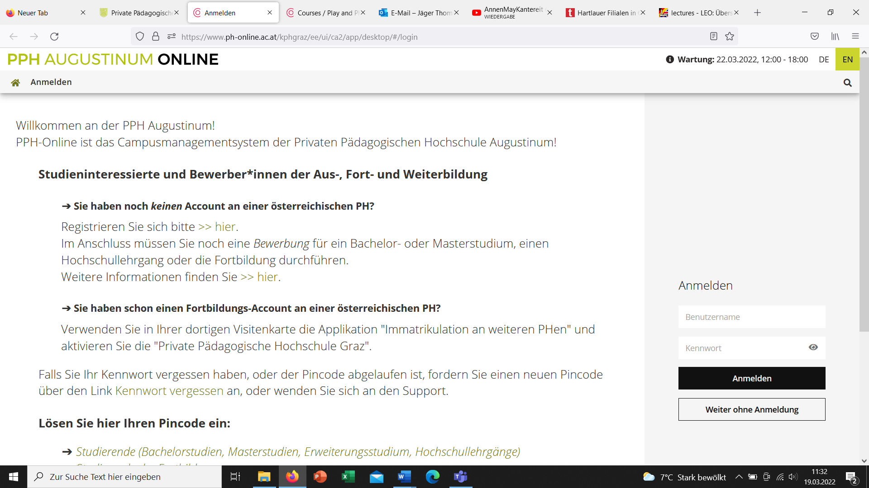

Switch language to „EN“

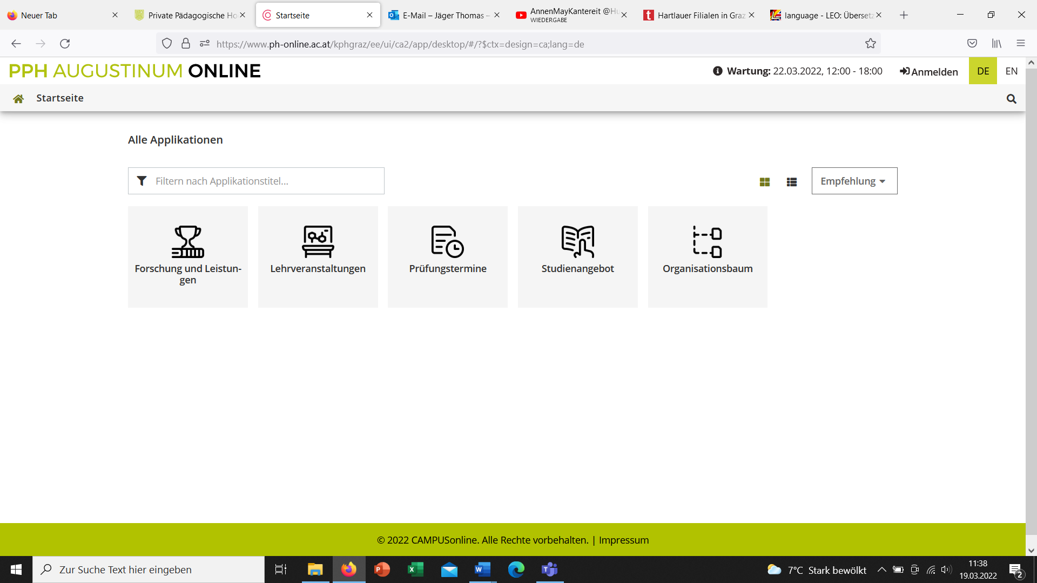

To find your lectures choose the application „courses“

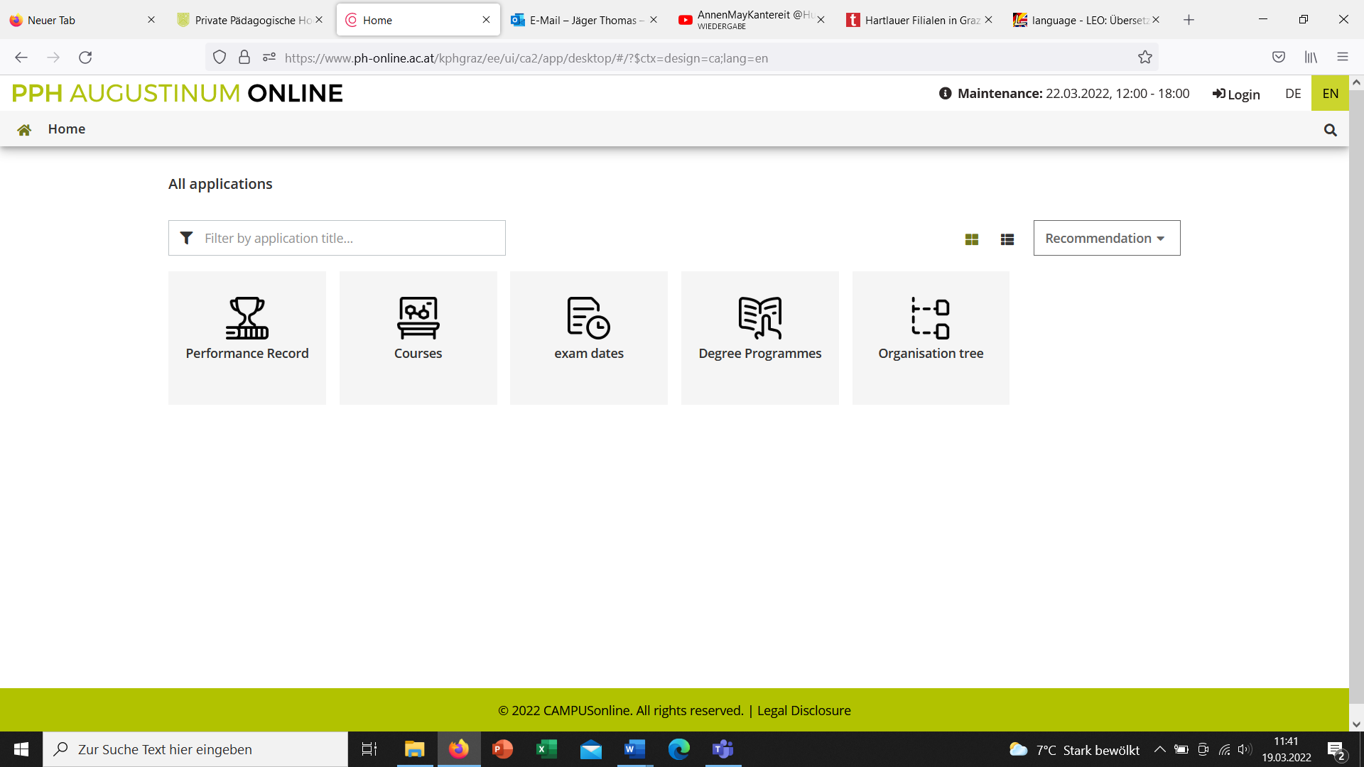

Type or copy the title or course number (if available) (e.g. you find it in the course catalogue: i. e. PB11LF0100 Communication and Foreign Language Teaching I – VU - 2 EC – Eisner-Fasching, Kaefel, Kessler, Reiter)
of the requested lecture in the filter field (see red circle)
Take care that the correct term is selected: year and „W“ for winterterm, „S“ for summerterm (see blue circle)

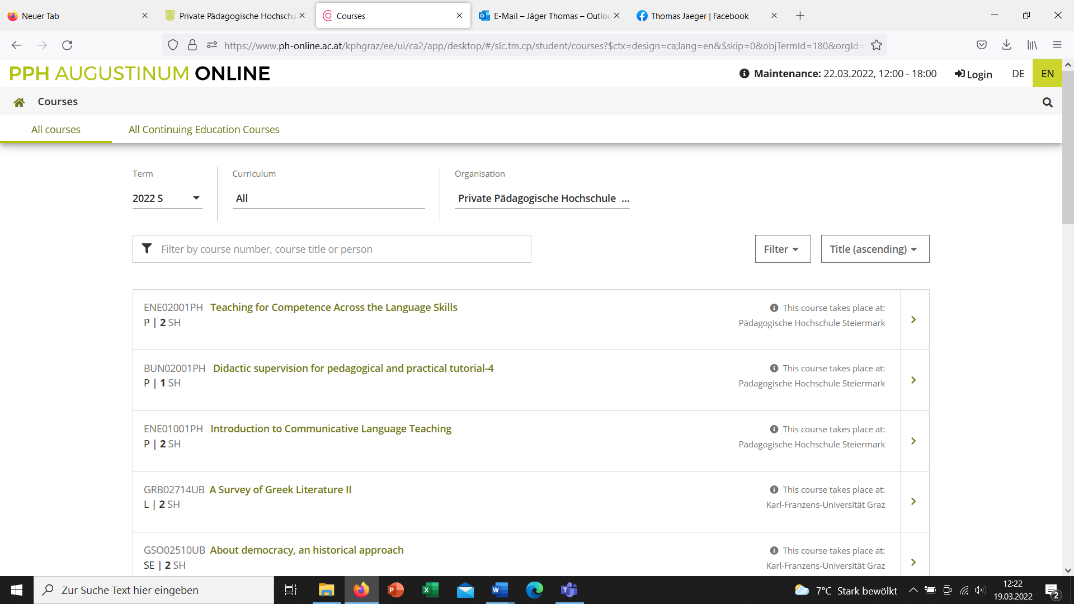

Your course gets opened and you can find all relevant information.

